Case Study Essay

The TCC Console Architecture
Evaluate the decision of the TCC engineering team to utilize a heterogeneous CPU/GPU architecture and its reliance on the Primary Memory Hierarchy to manage the execution demands of a modern video game, considering the inherent limitations imposed by the Fetch-Decode-Execute cycle.
Introduction
The design of the "Compute Core (TCC)" console necessitates a robust architecture to meet the demanding computational and graphical requirements of modern gaming. The TCC engineering team has opted for a heterogeneous architecture, integrating a general-purpose Central Processing Unit (CPU) with a specialized Graphics Processing Unit (GPU). This decision directly addresses the performance limitations inherent in the traditional Von Neumann Architecture and the sequential nature of the Fetch-Decode-Execute (F-D-E) cycle. However, the success of this strategy is ultimately dependent on the efficient management of data through the Primary Memory Hierarchy. This essay will evaluate the necessity of the heterogeneous approach and the critical role of memory optimization in mitigating execution bottlenecks.
The CPU, F-D-E Cycle, and the Bottleneck
The CPU is the control center, optimized for sequential execution, complex control flow (e.g., conditional jumps), and low-latency access to any single piece of data. Its operation is governed by the F-D-E cycle, where the Control Unit (CU) fetches an instruction (via the Program Counter and Memory Address Register), decodes it, and executes it using the Arithmetic Logic Unit (ALU). This process is inherently serial.
While essential for managing game logic, AI decision trees, and operating system functions, the CPU's architecture is fundamentally ill-suited for the massive, highly repetitive, and parallel calculations required for 3D rendering (e.g., shading millions of pixels). When attempting such tasks, the CPU becomes trapped by the Von Neumann Bottleneck: the single shared bus for both instructions and data access drastically limits the speed at which the F-D-E cycle can be fed, resulting in excessive latency and low throughput. Therefore, the utilization of the CPU alone would be insufficient for a modern console, validating the need for a specialized component.

Evaluation of the GPU and Heterogeneous Architecture
The inclusion of a GPU validates the TCC team's decision to adopt a heterogeneous architecture. The GPU employs a Single Instruction, Multiple Data (SIMD) design, containing thousands of simpler Stream Processors. This architecture bypasses the Von Neumann sequential limitations by executing the same instruction on vast amounts of data simultaneously.
- Necessity: The GPU is essential for achieving high frame rates and graphical fidelity, handling tasks like complex texture mapping, lighting calculations, and real-time physics simulation with extremely high throughput.
- Synthesis Challenge: The challenge of this architecture lies in effectively coordinating the CPU (managing complex, divergent tasks) and the GPU (managing simple, parallel tasks). Data must be efficiently moved between the two, often requiring dedicated, fast VRAM for the GPU to prevent bandwidth constraints with the main system memory.
The decision to use both is an effective solution: the CPU retains its role as the general-purpose, low-latency control unit, while the GPU acts as a high-throughput parallel accelerator, overcoming the CPU's inability to handle massive rendering workloads.
The Critical Role of the Primary Memory Hierarchy
While the heterogeneous architecture addresses the execution model challenge, the performance of both the CPU (F-D-E cycle) and the GPU is critically dependent on the Primary Memory Hierarchy. This hierarchy, composed of Registers $\rightarrow$ Cache (L1, L2, L3) RAM (Main Memory), functions to minimize the time spent waiting for data.
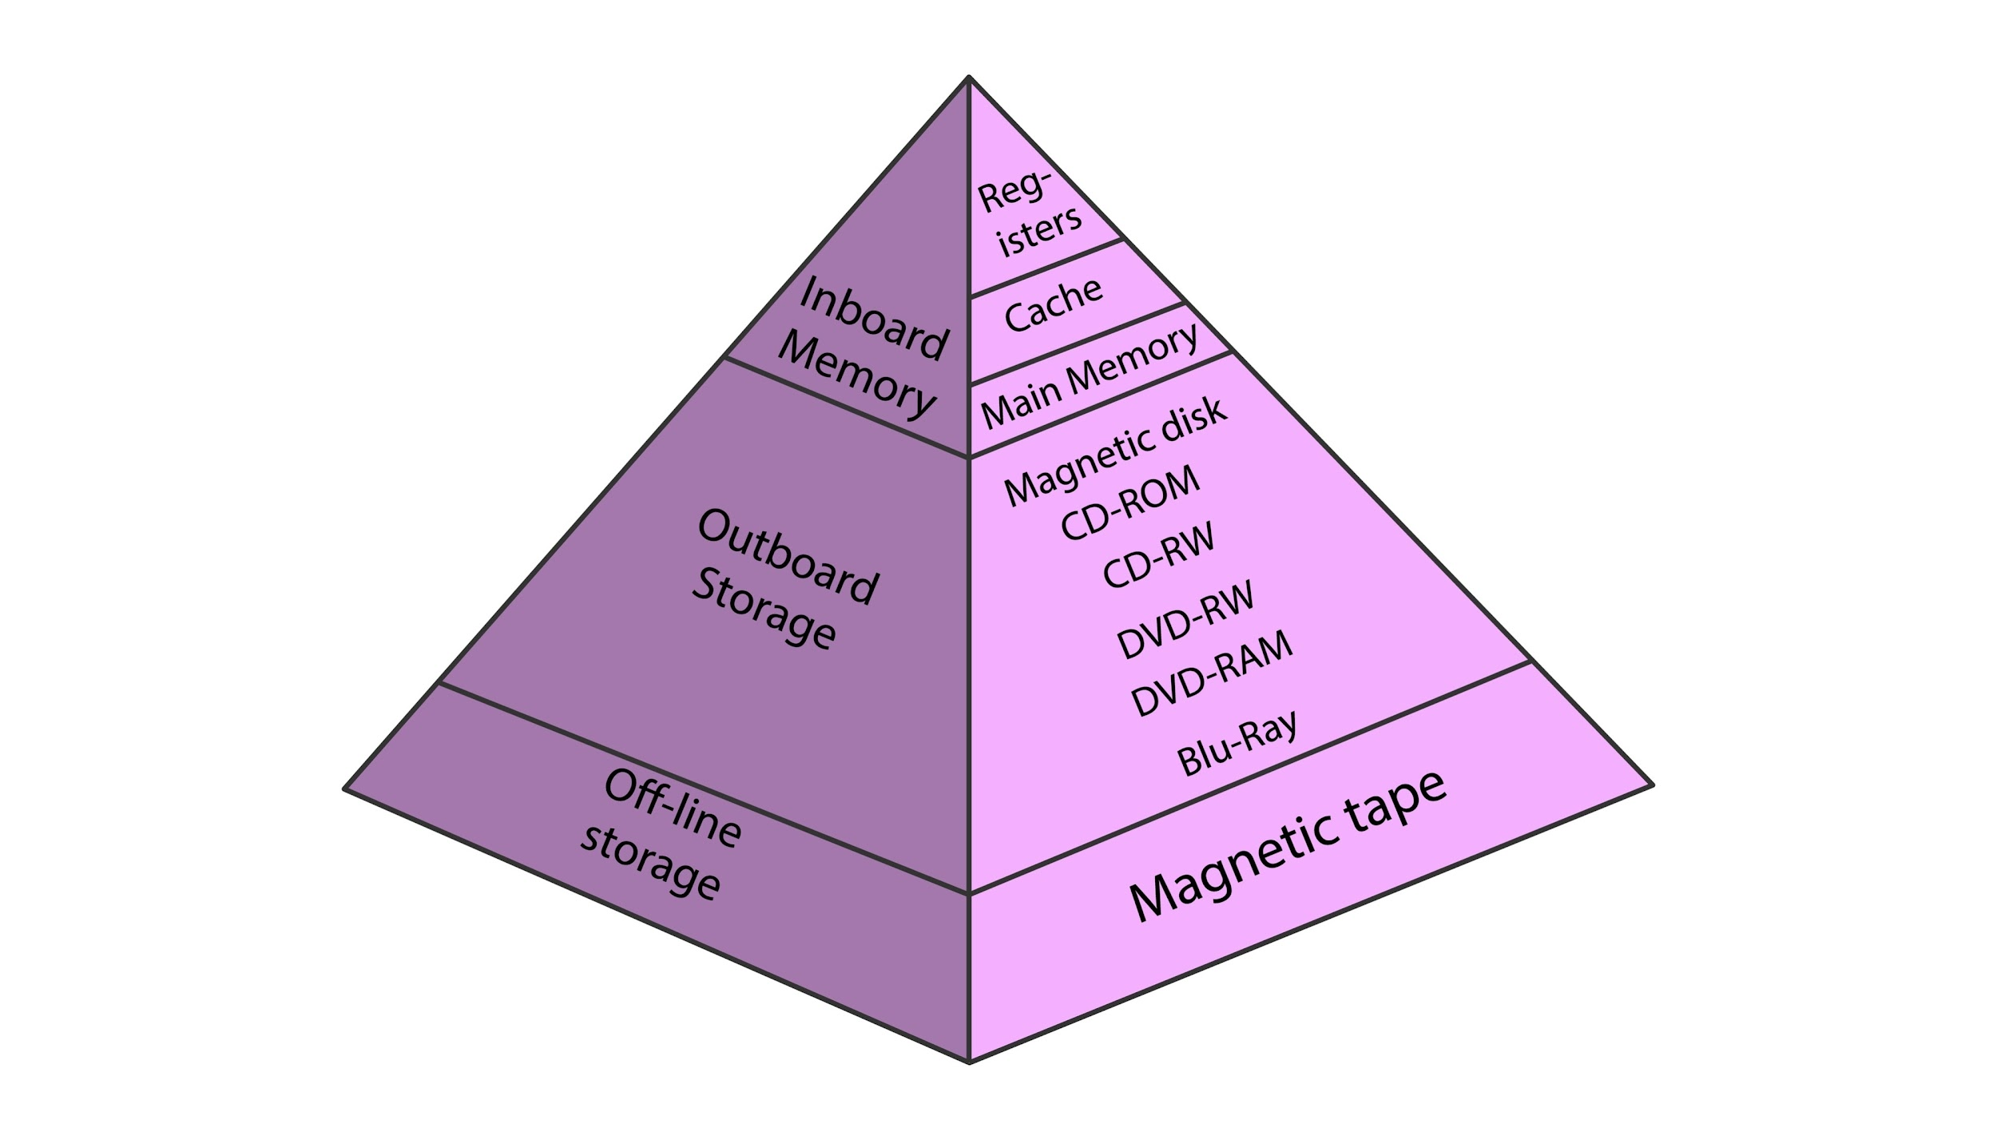
Shutterstock
- Mitigation of F-D-E Latency: The sequential nature of the F-D-E cycle means any delay in fetching an instruction or data from main memory (RAM) results in a significant stall. Cache memory is designed to exploit temporal and spatial locality, storing frequently used instructions and data near the CPU. A cache hit allows the CPU to complete the Fetch stage far faster than accessing RAM.
- Evaluation of Optimization: Evaluating the cost-benefit trade-off, investing heavily in larger, faster L1/L2 Cache is more critical than simply adding more RAM. The bottleneck is not typically capacity, but the latency involved in accessing main memory (the Memory Wall). A larger, more efficient cache directly reduces the impact of the Von Neumann Bottleneck by reducing the number of slow main memory accesses.
Conclusion
The TCC team's choice of a heterogeneous CPU/GPU architecture is a necessary and highly effective strategy to meet the performance demands of modern gaming. The GPU successfully bypasses the performance limitations of the CPU's sequential F-D-E cycle for parallel graphics tasks. However, the architectural success is fundamentally contingent upon the optimization of the Primary Memory Hierarchy. It is the efficient management and utilization of Cache memory that directly mitigates the core latency issues of the F-D-E cycle and the Von Neumann Bottleneck. Therefore, while the CPU/GPU split solves the problem of what gets executed, the memory hierarchy solves the problem of how fast execution can occur.

Glossary of Key IB Computer Science Terms
Here is a glossary of the essential terms used in the CPU/GPU case study, formatted for quick review by IB Diploma Computer Science students.

Processor Architecture
Term | Definition | Context in Case Study
CPU (Central Processing Unit) | The primary component that executes program instructions using the Fetch-Decode-Execute (F-D-E) cycle. Optimized for sequential execution and low-latency, complex tasks. | Manages game logic, AI, and system operations.
GPU (Graphics Processing Unit) | A specialized co-processor designed for parallel computation. Contains thousands of simpler cores (Stream Processors). Optimized for high-throughput tasks. | Essential for 3D rendering (shading, lighting, texture mapping) and massive physics calculations.
Heterogeneous Architecture | A system design that integrates different types of processors (e.g., CPU and GPU) where each processor is optimized for a specific set of tasks. | The foundation of the TCC console's design, leveraging the strengths of both CPU and GPU.
SIMD (Single Instruction, Multiple Data) | A parallel processing model where a single instruction is applied simultaneously to multiple data points. | The fundamental operational model of the GPU, enabling high-speed rendering.

Execution Cycle and Bottlenecks
Term | Definition | Context in Case Study
Fetch-Decode-Execute (F-D-E) Cycle | The fundamental sequence of operations performed by the CPU: Fetch instruction from memory, Decode the instruction, and Execute the operation. | The sequential process that forms the foundation of CPU activity; its speed directly impacts performance.
Program Counter (PC) | A register inside the CPU that stores the address of the next instruction to be fetched. | Essential for controlling the flow of the F-D-E cycle, particularly during conditional jumps.
Control Unit (CU) | A component of the CPU that directs and coordinates the F-D-E cycle, sending control signals to all other components. | Ensures correct sequencing and timing of operations.
Von Neumann Bottleneck | A limitation of the Von Neumann architecture caused by the CPU and main memory sharing a single bus for both data and instructions, limiting the speed of data transfer. | The key limitation the TCC console must overcome, primarily by using the GPU and efficient memory access.

Term | Definition | Context in Case Study
Primary Memory (Internal Memory) | Memory directly accessible by the CPU, holding data and instructions currently being used. Includes Registers, Cache, and RAM. | Critical for providing high-speed access to the CPU/GPU.
Registers | Small, extremely fast storage locations inside the CPU. They hold data currently being processed (e.g., MAR, MDR, PC). | Fastest level of memory; used to hold immediate data for the F-D-E cycle.
Cache (L1, L2, L3) | Small, fast memory buffer between the CPU and RAM, storing frequently accessed data and instructions. | Crucial for mitigating the F-D-E cycle's latency by exploiting Locality of Reference (Temporal and Spatial).
RAM (Random Access Memory) | Main system memory. Larger and slower than cache but faster than secondary storage. Stores the operating system and running programs/data. | Holds the large datasets (textures, physics) required by the running game.
Cache Miss | An event where the CPU requests an instruction or data item that is not currently stored in the cache, forcing the system to access the much slower main memory (RAM). | Directly increases the latency of the F-D-E cycle and reduces overall performance.

